Smart water fountain

## Phase-4

Project requirements:

When defining project requirements for a smart water fountain in IoT, it’s important to consider various aspects to ensure a successful implementation. Here are some key project requirements to consider:

1. **Hardware Components:**

- Specify the type of water fountain to be used and any necessary modifications or additions for IoT integration.

- Define the choice of microcontroller or IoT hardware platform (e.g., Arduino, Raspberry Pi) to control and monitor the fountain.

2. **IoT Capabilities:**

- Specify the sensors and actuators required for monitoring and controlling the water fountain. This may include water level sensors, pumps, valves, and flow meters.

3. **Connectivity:**

- Determine the network connectivity options, such as Wi-Fi, Ethernet, or cellular, for the smart fountain to connect to the internet.

4. **User Interface:**

- Define the requirements for the user interface, including a web-based control panel, a mobile app, or both.

- Specify the features and functionalities of the user interface, such as fountain control, monitoring, and data visualization.

5. **Data Management:**

- Identify the types of data to be collected and stored, such as water consumption data, user preferences, and fountain status.

- Specify the database system and data storage requirements.

6. **IoT Protocols:**

- Determine the communication protocols to be used for device-to-server and device-to-user interactions (e.g., MQTT, CoAP).

7. **Security:**

- Define security requirements, including user authentication and authorization mechanisms.

- Specify data encryption for secure data transmission and storage.

8. **Notifications:**

- Specify the types of notifications required, such as alerts for low water levels, maintenance needs, or user interaction.

9. **Remote Control:**

- Define the extent of remote control over the water fountain, including on/off control, flow rate adjustments, and scheduling.

10. **Power Supply:**

- Determine the power source and power management for the IoT device, considering battery life or power efficiency.

11. **Scalability:**

- Consider the potential for adding more fountains or expanding the system to multiple locations.

12. **Data Analytics (Optional):**

- Specify any data analysis or machine learning requirements for optimizing fountain performance or predicting maintenance needs.

13. **Compliance:**

- Ensure that the project complies with any relevant industry standards or regulations, especially regarding water usage and safety.

14. **Budget and Timeline:**

- Define the project budget and timeline, including development, testing, and deployment phases.

15. **Testing and Quality Assurance:**

- Outline testing requirements, including unit testing, integration testing, and user acceptance testing.

16. **Documentation and Training:**

- Specify the need for documentation, including user manuals and developer guides, and any training for users or maintenance personnel.

17. **Maintenance and Support:**

- Describe the post-launch maintenance and support plan, including regular updates and troubleshooting.

18. **Deployment and Integration:**

- Determine how the smart fountain will be installed, integrated with existing systems (if any), and made accessible to users.

19. **User Feedback and Iteration:**

- Plan for collecting user feedback and making improvements based on user experiences.

20. **Data Privacy and GDPR (General Data Protection Regulation) Compliance:**

- Ensure that user data is handled in compliance with data protection regulations, especially if personal information is collected.

By clearly defining these project requirements, you’ll have a solid foundation for the design, development, and successful implementation of your smart water fountain IoT project. It’s crucial to involve all stakeholders, including IoT engineers, web developers, and end-users, in this process to ensure the project aligns with their needs and expectations.

## Web development TECHNOLOGIES

To create a smart water fountain in an IoT (Internet of Things) context, you can use a variety of web development technologies. Here’s a brief overview of the components and technologies you might consider:

1. **Hardware Components:**

- **Water Fountain Hardware:** You’ll need the physical water fountain itself with IoT capabilities (sensors, actuators, and controllers).

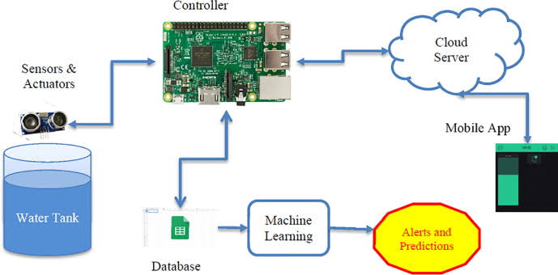 - **Microcontroller:** Often, you’ll use microcontrollers like Arduino or Raspberry Pi to interface with the fountain and connect it to the internet.

2. **IoT Protocols:**

- **MQTT or CoAP:** These lightweight protocols are commonly used for IoT devices to transmit data efficiently.

3. **Web Development Technologies:**

- **Web Application:** Create a web-based control panel for users to interact with the smart fountain. You can use HTML, CSS, and JavaScript for the frontend.

- **Backend Server:** Develop a backend server to handle data from the fountain and manage user interactions. You can use Node.js, Python (Django or Flask), or other server-side technologies.

- **Database:** Store data about fountain usage, water levels, and user preferences in a database. MySQL, PostgreSQL, or NoSQL databases like MongoDB are options.

- **APIs:** Create RESTful or GraphQL APIs for communication between the IoT device and the web application.

- **WebSocket:** Use WebSocket for real-time communication if you need instant updates on the fountain’s status.

- **Cloud Services:** Consider using cloud platforms like AWS, Google Cloud, or Azure for scalability and remote access.

4. **IoT Platform:**

- **IoT Platform:** You can use IoT platforms like AWS IoT, Google Cloud IoT, or Microsoft Azure IoT to manage device connectivity, data processing, and security.

5. **Security:**

- **HTTPS:** Ensure secure communication between the web application and the smart fountain using HTTPS.

- **Device Authentication:** Implement strong authentication and authorization for both users and the IoT device.

- **Data Encryption:** Encrypt sensitive data, especially user credentials and device commands.

6. **Data Visualization:**

- **Data Visualization Libraries:** Use libraries like D3.js or Chart.js to display real-time data and statistics about the water fountain on the web application.

7. **Mobile App (Optional):**

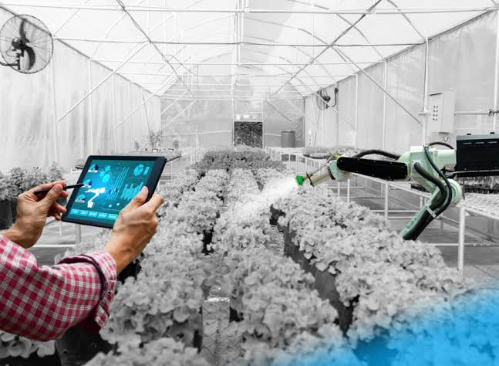 - **Mobile App Development:** Consider creating a mobile app for users to control and monitor the smart water fountain on their smartphones. You can use native development (e.g., Swift or Kotlin) or cross-platform frameworks like React Native or Flutter.

8. **User Authentication:**

- Implement user authentication to ensure that only authorized users can control the fountain. You can use OAuth2, JWT, or other authentication methods.

9. **Notifications:**

- Send push notifications or emails to users for alerts, such as low water levels or filter replacements.

10. **Machine Learning (Optional):**

- If you want to add predictive or smart features, you can use machine learning to analyze data from the fountain and improve its performance.

Remember that the specific technologies and components you choose may depend on your project’s requirements and constraints. Building a smart water fountain in IoT involves integrating hardware, networking, and web development, so it’s essential to plan and design the system carefully.

### Web development technologies NEEDED:

In a smart water fountain IoT project, web development technologies are typically used in the user interface, remote control, and data management aspects. Here's where you might need web development technologies:

1. **User Interface (UI):**

- **HTML and CSS:** These fundamental web technologies are used to structure and style the user interface for controlling and monitoring the smart water fountain.

2. **Frontend Development:**

- **JavaScript:** For creating interactive features on the user interface, such as buttons, sliders, and real-time data updates.

- **Frontend Frameworks:** Utilize frontend frameworks like React, Angular, or Vue.js for building dynamic and responsive user interfaces.

3. **Backend Development:**

- **Server-Side Scripting:** Use server-side technologies like Node.js, Python (Django or Flask), Ruby on Rails, or Java to handle backend logic.

- **Web APIs:** Develop RESTful or GraphQL APIs to communicate with the smart water fountain and retrieve or send data.

4. **Database Management:**

- **Database Systems:** Set up a database (e.g., MySQL, PostgreSQL, MongoDB) to store information about water levels, usage statistics, and user preferences.

- **ORMs (Object-Relational Mapping):** Implement ORMs like Sequelize (Node.js), Django ORM (Python), or Hibernate (Java) to simplify database interactions.

5. **Real-time Communication:**

- **WebSockets:** Use WebSocket technology for real-time communication between the smart fountain and the user interface. This is particularly useful for providing instant feedback on fountain status.

6. **Cloud Integration:**

- **Cloud Services:** Consider using cloud platforms like AWS, Google Cloud, or Azure to host your web application and database for scalability and accessibility.

7. **Security:**

- **HTTPS:** Secure the communication between the user interface and the smart fountain with HTTPS.

- **User Authentication:** Implement user authentication mechanisms to ensure secure access to the control panel.

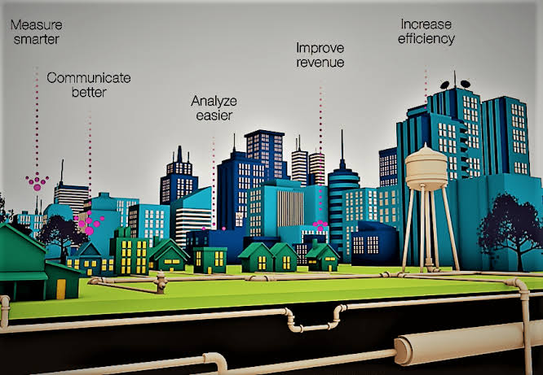 - **Data Encryption:** Encrypt sensitive data such as user credentials and device commands.

8. **Notifications:**

- **Email Services:** Use email services (SMTP) to send notifications to users, such as low water level alerts.

9. **Data Visualization:**

- **Data Visualization Libraries:** Employ data visualization libraries such as D3.js or Chart.js to display real-time data and statistics about the water fountain.

10. **Mobile App (Optional):**

- If you want a mobile application for controlling the smart water fountain, use web technologies such as React Native, Flutter, or a combination of native technologies (Swift, Kotlin) to build the app.

These web development technologies are used in various components of your smart water fountain IoT project to enable user interaction, real-time monitoring, and data management. The specific technologies you choose will depend on your project’s requirements and your development team’s expertise.